Name: Sandesh Varma                                                                     Date: 15/09/2025

Roll No: CH.EN.U4CSE22078

Experiment No: 7

___________________________________________________________________

Aim: To implementation of Code Optimization Techniques

# **Algorithm:**

# Start the program

# Declare the variables and functions.

# Enter the expression and state it in the variable a, b, c.

# Calculate the variables b & c with ‘temp’ and store it in f1 and f2.

1. If(f1=null && f2=null) then expression could not be optimized.
2. Print the results.
3. Stop the program.

Code:

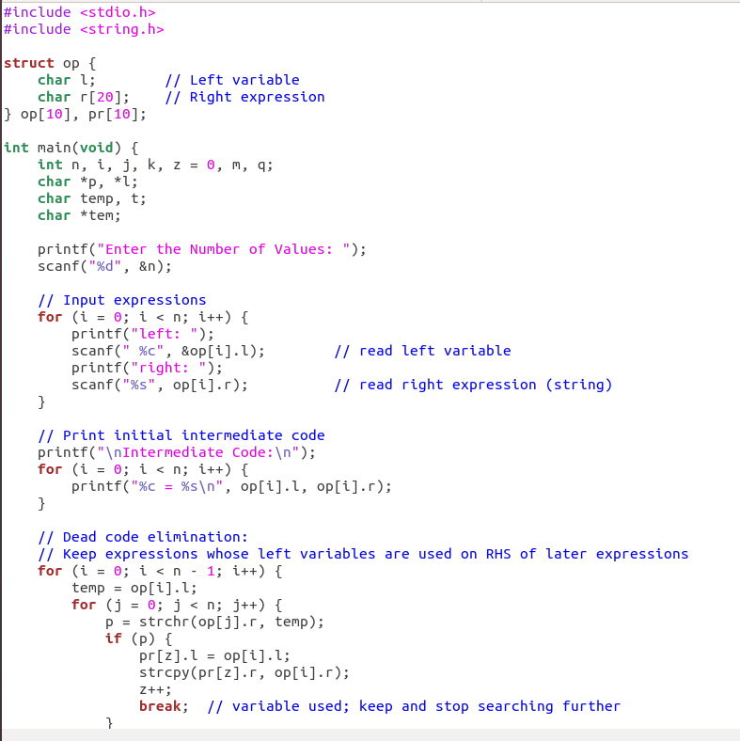

Sandesh Varma

CH.EN.U4CSE22078

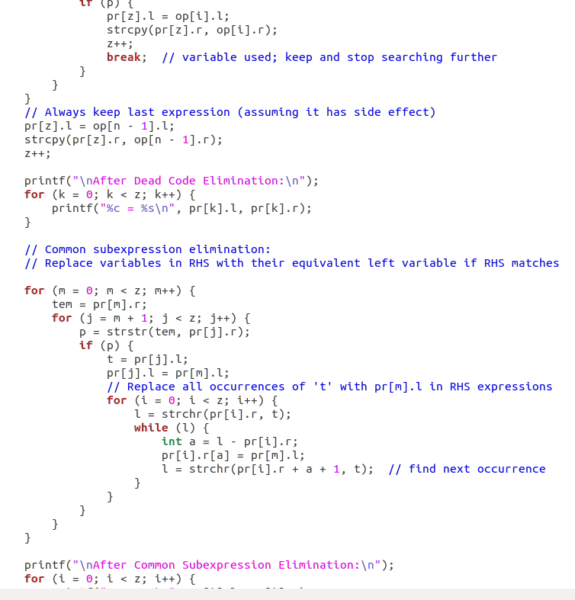

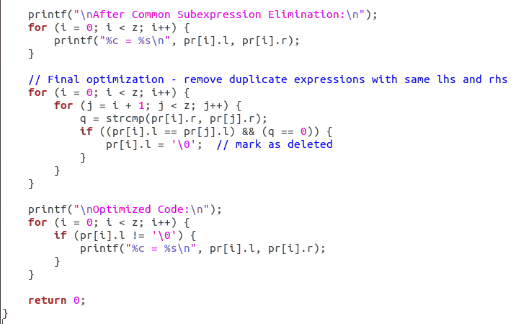

Sandesh Varma

CH.EN.U4CSE22078

Output:

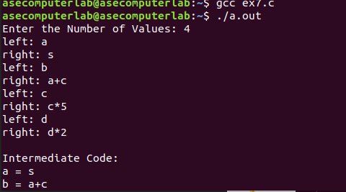

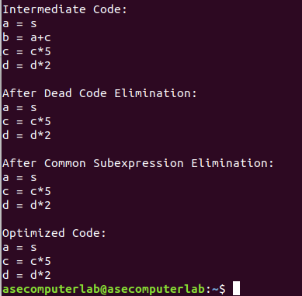

Results: The program for the implementation of Code Optimization Techniques

has been executed successfully.